1. Write a C program to perform Matrix Multiplication

PROGRAM:

#include <stdio.h>

#define N 3

void multiplyMatrix(int firstMatrix[][N], int secondMatrix[][N], int resultMatrix[][N]) {

for (int i = 0; i < N; i++) {

for (int j = 0; j < N; j++) {

resultMatrix[i][j] = 0;

for (int k = 0; k < N; k++) {

resultMatrix[i][j] += firstMatrix[i][k] \* secondMatrix[k][j];

}

}

}

}

int main() {

int firstMatrix[N][N] = {{1, 2, 3}, {4, 5, 6}, {7, 8, 9}};

int secondMatrix[N][N] = {{9, 8, 7}, {6, 5, 4}, {3, 2, 1}};

int resultMatrix[N][N];

multiplyMatrix(firstMatrix, secondMatrix, resultMatrix);

printf("Resultant Matrix:\n");

for (int i = 0; i < N; i++) {

for (int j = 0; j < N; j++) {

printf("%d ", resultMatrix[i][j]);

}

printf("\n");

}

return 0;

}

INPUT:

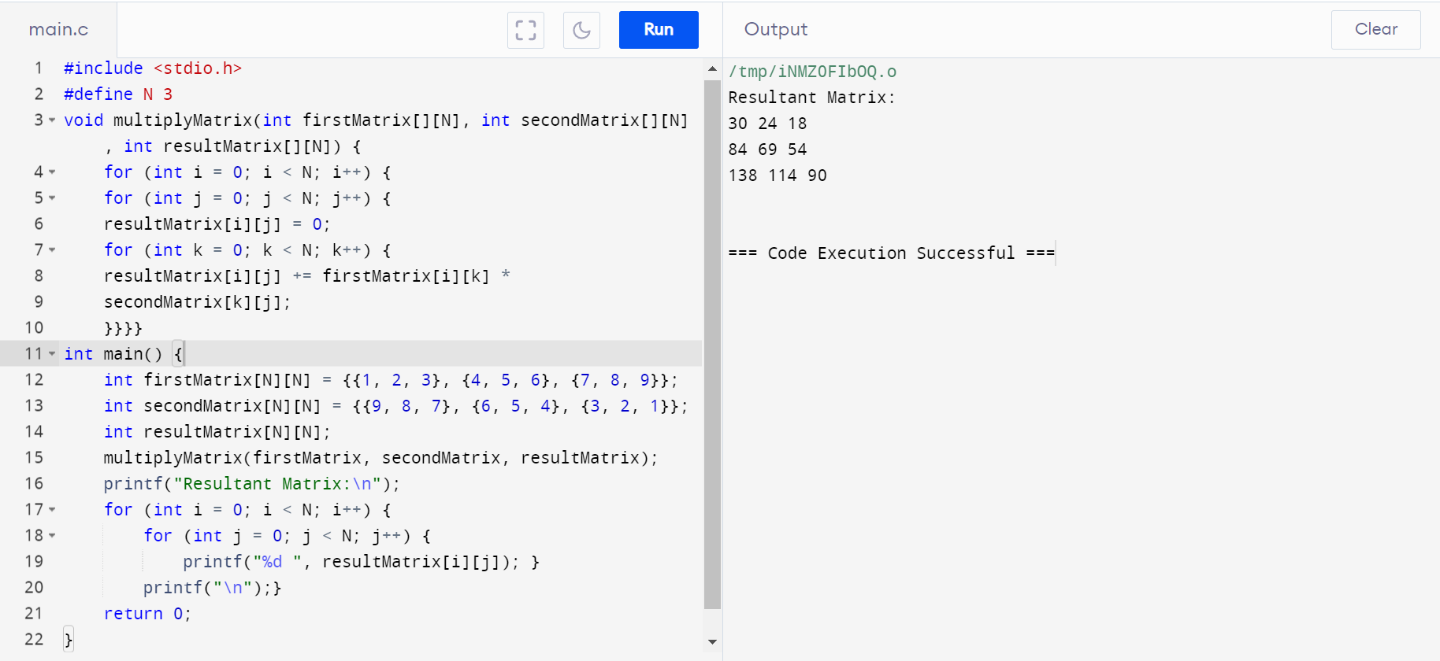

OUTPUT:

